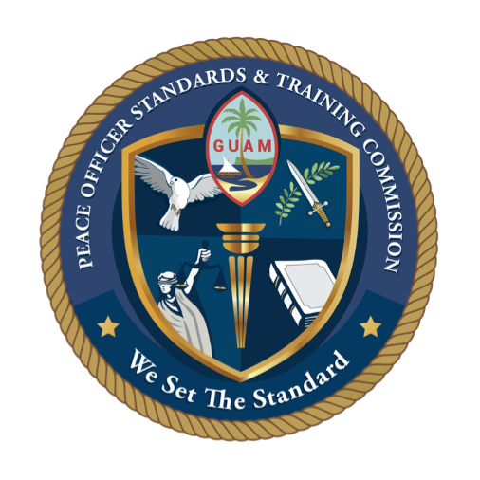

**GUAM PEACE OFFICER STANDARDS**

**& TRAINING COMMISSION (POST)**

(671) 735-5610 | P.O. Box 23069 GMF, Barrigada, Guam 96921

**AGENDA**

**August 1, 2024 (Thursday) / 10:30 a.m.**

**Guam P.O.S.T. Commission Meeting**

**Room 112, Learning Resource Center**

**(GCC Library), Building 4000**

Livestream: <https://www.youtube.com/channel/UC5qBgb8LX6AMPxyiFGCImWQ>

1. Call to Order, Roll Call by Agency and Name
2. Review & Approval of Minutes from April 5, 2024 Regular Meeting
3. Chairman/Vice Chairman Remarks
4. Old Business **(TABLED)**
   1. General Force Leadership Structure Tier
   2. POST Commission Regulations. Peace Officer Certification of Departments/Agency’s (Pending)
   3. Discussion on how to Incentivize the Physical Fitness Test (Pending)
   4. Discussion on Implementation of INTEREIM RECRUITMENT PROCESS to provide sworn LEO’s more expediently to LE Agencies (Pending)
   5. Medical Program/Medical Profiles/POST Decertification (Pending)
      1. Medical Profiles – Further discussion on how to deal with extended medical profiles moving forward. Plan of action to address these concerns moving forward.
      2. POST Standard on Comprehensive Occupational Medical Program (Refer to presentation by POST Vice-Chair)
      3. POST Development of Rules and Process for Peace Officer Decertification (Formalize a committee to establish plan of action to be developed moving forward. POST Vice-Chair
5. New Business
   1. POST Chairman’s Letter to the Governor
   2. Administrative Support
   3. Amendment to Title 27, Chapter 3, Section 3106(b)(1) Category I (Minimum Training Program) ADD: EVOC, Dynamics of Substance Abuse, Traffic Law Enforcement, and Criminal Investigations

***POST - Meeting Agenda***

***August 1, 2024***

***Page 2***

* 1. Amendment to Title 27 Guam Administrative Rules, Chapter 3, Section 3106(b)(1) ADD (F) Temporary Certification. An individual may upon application obtain temporary certification while completing specific courses specified by the Commission.
  2. PoliceOne and Fire/Rescue1 Update
  3. Election of POST Chairman and Vice-Chairman

1. Open Discussion/Announcements
2. Next Meeting – October 3, 2024 at 10:30 am
3. Adjournment